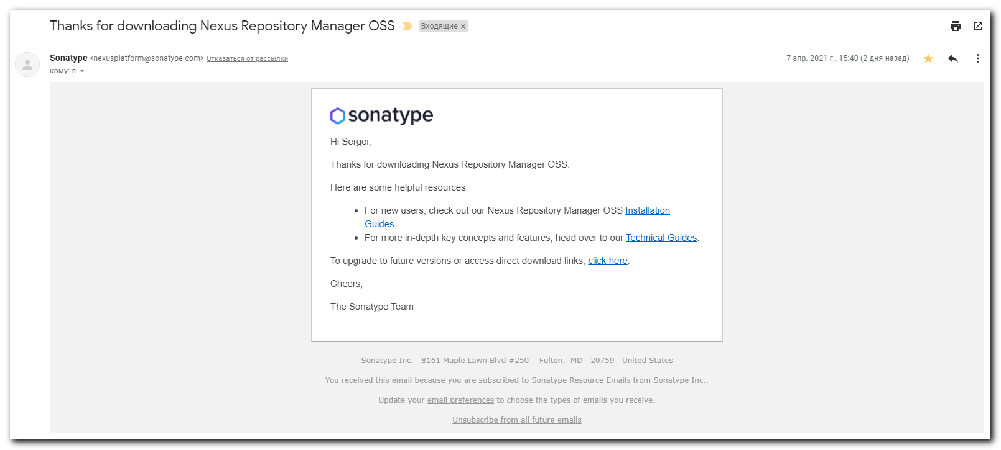

#
# 20210409
#
# To upgrade to future versions or access direct download links, click here.
#
https://www.sonatype.com/e2t/tc/VWm0h-8qp3Z0W5RZ4RC6LLBMWW4zFhY94q5hWLN5JQGly3p_97V1-WJV7CgQwhW5CfH0K37zhPcW81h8Y_2TxNy3W1w6qdB3QDY_sW1rcfpn50V6CLW1r-8N51pjlCRW3b07ln5LRmDYW8V1KWK5C42jtW21mgs53VHpZtW15N7HH79LpMJW5Sdyvs5GVWjjW6C41fv8yd37lVmnN57791d1FVC96Rl8Qr3kFW60Wn8f48f1T0W1TKHrC7Qkv7JW1lsGFh6PJLLXW69vx_R3P0rghW5ryKS74Qwk0tV_kbB-6RF-5cW4crx1_8F748PW6PvH9t644Y08W8sZ6gj7Gnct8W8pLmY27gqMV_N8tjMH_VZD-X34FM1

https://help.sonatype.com/repomanager3/installation?utm_campaign=2019%20Repo%20OSS&utm_medium=email&_hsmi=102690947&_hsenc=p2ANqtz-8agsGlvOng9QkI7Ll8fYehiL_155I8_f-K_Gj71IqmgcwSf97SRCw2cBPeDO6g9uUbKtNgEhd-A3HlgJL1tKCob48ACg&utm_content=102690947&utm_source=hs_automation

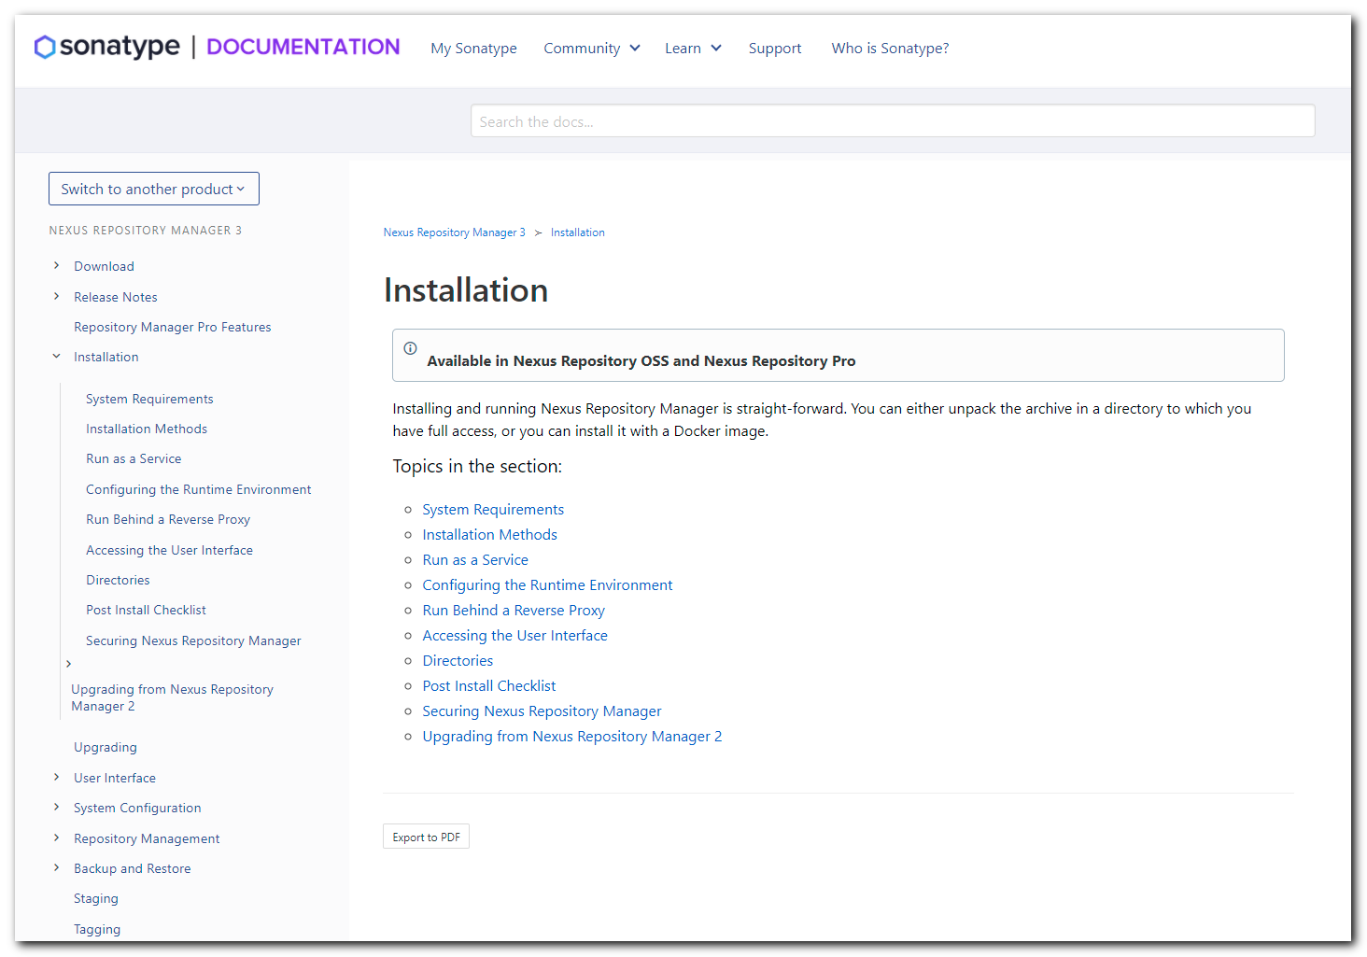

https://help.sonatype.com/repomanager3/download?utm_campaign=2019%20Repo%20OSS&utm_medium=email&_hsmi=102690947&_hsenc=p2ANqtz-_OLJGGj1S-CdEJcYud4WZsjqDJyOgnaD71DcY56HxH4UAmvQZ8JNLW1kxNZXXiLd4lPmqjSxlIi5t6DZYzavR06xpT5g&utm_content=102690947&utm_source=hs_automation

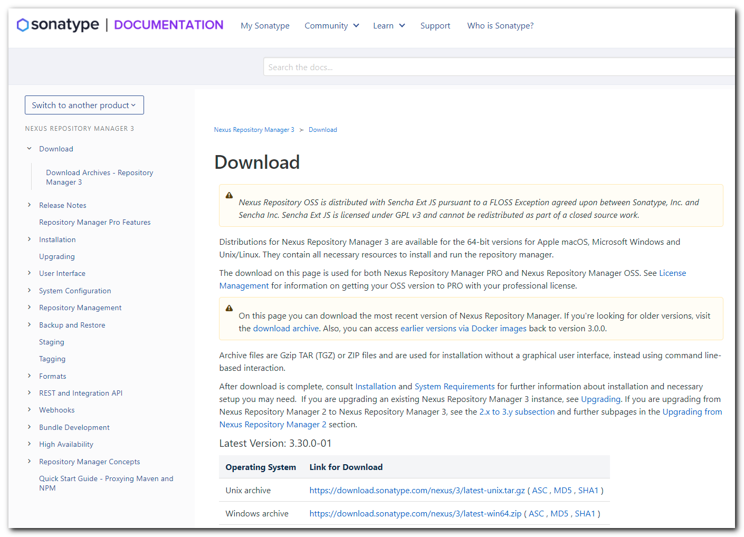

https://guides.sonatype.com/repo3/technical-guides/?utm_campaign=2019%20Repo%20OSS&utm_medium=email&_hsmi=102690947&_hsenc=p2ANqtz-9eOilscLT2Mfc2XvN8P215kXvQNw3ZZeWC_Jg2CIU5JeAd45Zm99y_GeqItw58yhs3QXX5-4joVJ1Xl3CjnOQ9wO6gTQ&utm_content=102690947&utm_source=hs_automation

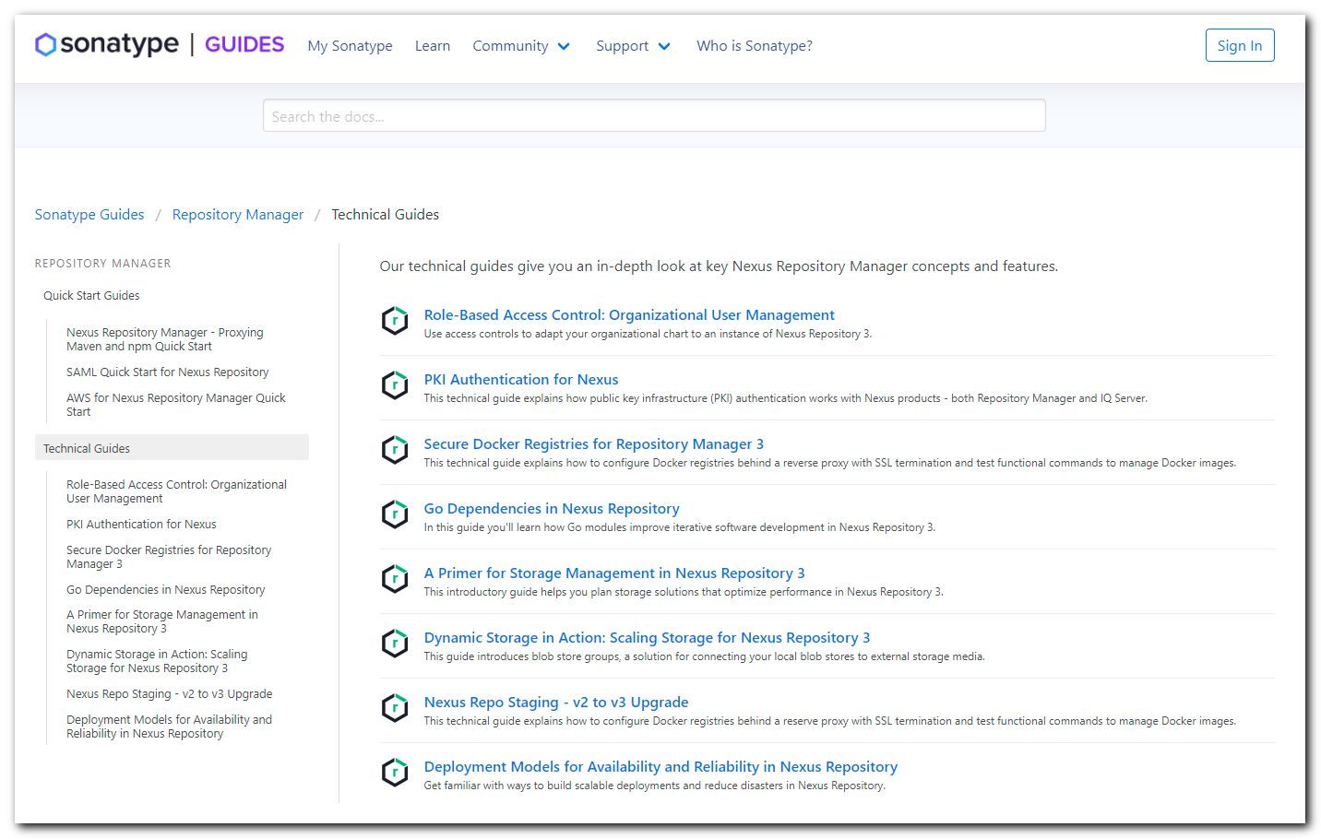

#
# This is a link, where I found bug description.
#
https://issues.sonatype.org/browse/NEXUS-27013

# And similar.
https://issues.sonatype.org/browse/NEXUS-27020?jql=project%20%3D%20NEXUS%20AND%20component%20%3D%20%22Raw%22
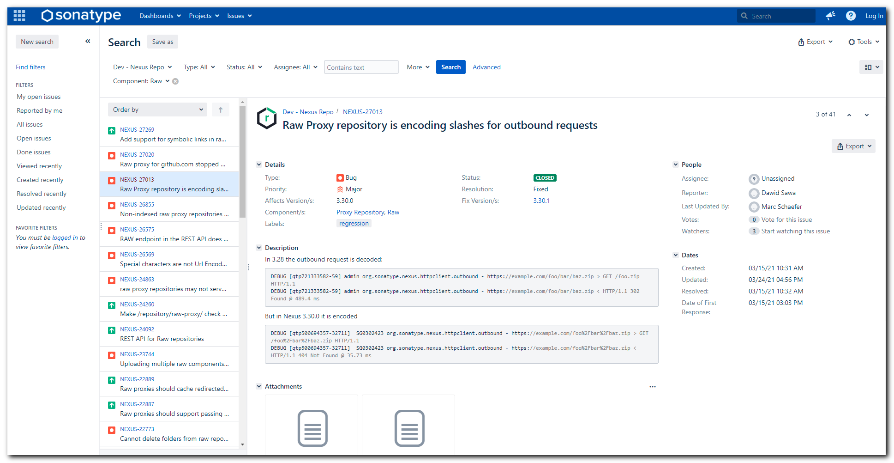

#
# It's look like a new. But how to get this page from the site menu - I don't know.
#
https://community.sonatype.com/t/nexus-repository-3-30-0-released/5997

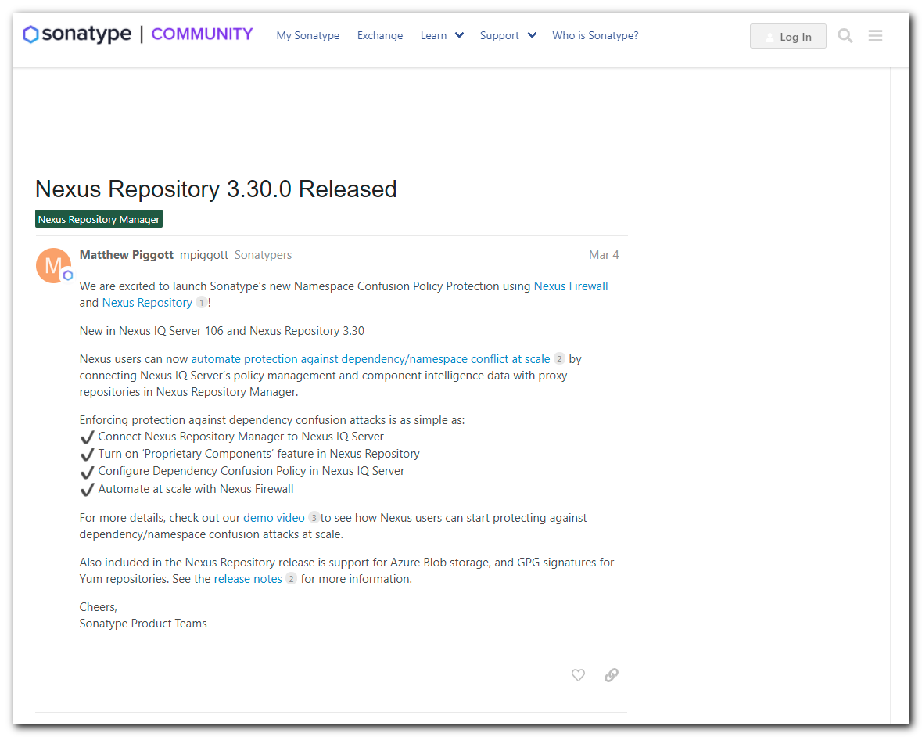

https://blog.sonatype.com/sonatype-releases-new-nexus-firewall-policy-to-secure-software-supply-chains-from-dependency-confusion-attacks
